1 (a) Define
- systematic errors

………………………………………………………………………………………..

…………………………………………………………………………………… [1]

- random errors

………………………………………………………………………………………..

.……………………………………………………………………………………[1]

A student set up the circuit shown in Fig. 1.1 in order to determine the resistance of a wire and hence the resistivity of the metal of the wire.

A
V

wire

Fig. 1.1

The ammeter and voltmeter were both digital.

- State one possible random error which could occur in the use of the digital meters. How could this error be kept to a minimum value?

………………………………………………………………………………

………………………………………………………………………………

……………………………………………………………………………. [2]

- Explain why the voltmeter must have a resistance much greater than that of the wire in order to avoid a systematic error in the use of the ammeter.

……………………………………………………………………………….

……………………………………………………………………………….

……………………………………………………………………………….

…………………………………………………………………………… [3]

(c) The following readings were obtained for the experiment in (b).

Reading of voltmeter = ( 1.30 ± 0.01 ) V
Reading of ammeter = ( 0.76 ± 0.01 ) A
Length of wire = ( 75.4 ± 0.2 ) cm
Diameter of wire = ( 0.54 ± 0.02 ) mm

Calculate, with its actual uncertainty, the value of

- the resistance of the wire,

Resistance = ………..………………. Ω [3]

- the resistivity of the metal of the wire,

Resistivity = ………...……………. Ωm [3]

- Fig. 2.1 shows a pole vaulter holding a uniform pole horizontally. He keeps the pole in equilibrium by exerting an upward force, U, with his leading hand, and a downward force, D, with his trailing hand.

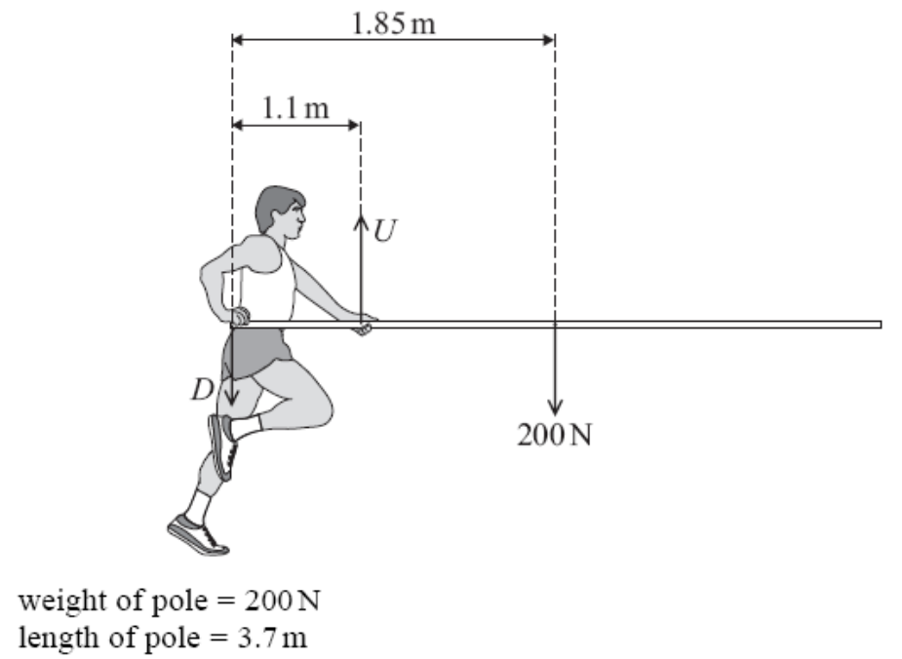

Fig. 2.1

(a) Calculate for the situation shown in Fig. 2.1,

- the force, U,

U = ……………….…. N [2]

- the force, D

D = ……………..……. N [2]
  - State and explain the effect on the magnitudes of U and D if the vaulter moves his leading hand closer to the centre of gravity of the pole and the pole is still in equilibrium.

............................................................................................................................................

............................................................................................................................................

............................................................................................................................................

............................................................................................................................................

............................................................................................................................................

....................................................................................................................................... [4]

- The graph shows how the velocity, v, of a car varies with time, t.

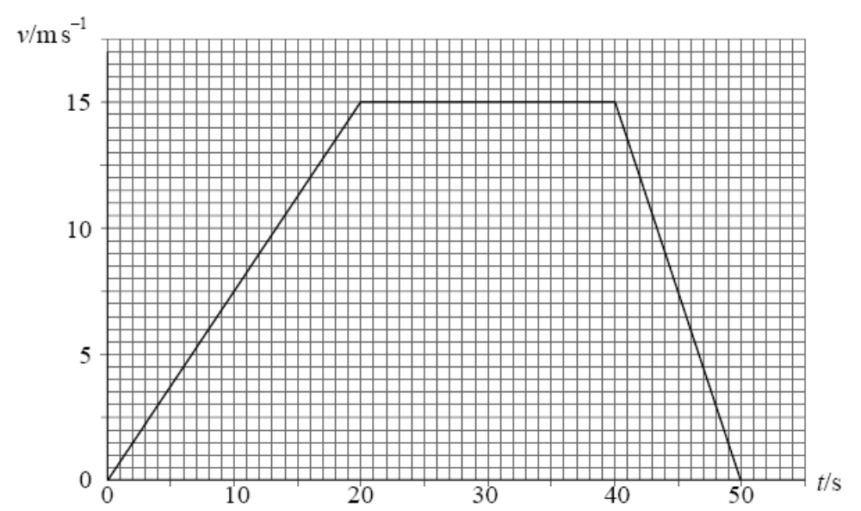

  - Describe the motion of the car for the 50 s period.

............................................................................................................................................

............................................................................................................................................

............................................................................................................................................

............................................................................................................................................

............................................................................................................................................

..................................................................................................................................... [3]

(b) The mass of the car is 1200 kg. Calculate for the first 20 s of motion,

- the change in momentum of the car,

change in momentum = …….………. kg m s⁻¹ [2]

- the rate of change of momentum,

rate of change of momentum = …………………. N [2]

- the distance travelled.

distance = ………………….. m [2]

4 Fig. 4.1 shows the experimental set up to determine the Young modulus of
steel.
Two long and thin steel wires are hung from the ceiling. One wire carries a
main scale and the other carries a vernier scale and a load.
vernier scale
main
scale
load
ceiling

Fig. 4.1

(a) What is meant by Young modulus?

……………………………………………………………………………. [1]

(b) Explain why, in the experimental set-up above
(i) two identical wires are used,

………………………………………………………………………………

……………………………………………………………………………….[1]

(ii) the wires are long and thin.

……………………………………………………………………………...

……………………………………………………………………………..[1]

(c) Describe briefly how the Young modulus of steel is determined from this
experiment.

……………………………………………….……………………………………..

…………………………………………………….……………………………….

………………………………………………….………………………………….

……………………………………………………………………………………...

……………………………………………………………………………………..

………………………………………………………………………………………

……………………………………………………………………………………[4]

5 A beam of light containing violet light and red light is directed perpendicularly at a
diffraction grating having 455 lines per mm. The first order violet light emerges at
an angle of 11.8º and the first order red light at an angle of 15.8º.
(a) Calculate
(i) the grating spacing

grating spacing = ………………… m [1]

(ii) the wavelengths of these two colours.

wavelength of red light = ……………............ m

wavelength of violet light = ……………………. m [3]
(b) At a certain angle, the red and the violet light overlap for the first time. At this
angle, the nth order of the red light coincides with the adjacent order of the violet
light.
(i) Calculate the ratio of the nth order of red light to that of the violet light.
Express your answer in the ratio of 2 integers.

ratio = ………………… [2]

(ii) Hence find the angle at which the red light and the violet light overlap.

angle = ……………………º [2]
6 Fig. 6.1 shows two large vertical parallel plates separated by a distance of
3.0 cm. Plate X is connected to a potential of +50 V and plate Y is connected to a
potential of -50 V.
-50 V
+50 V
3.0 cm
Y
X
x

Fig. 6.1

(a) Calculate the electric field E in the region between the plates.

E = ……………………. V m⁻¹ [1]
(b) An electron is released from rest at plate X. Just before the electron strikes the
plate Y, what is

(i) its kinetic energy?

kinetic energy = ………...……….…. J [1]
(ii) its velocity?

velocity = …………………….. m s⁻¹ [1]

(c) Deduce, for the electron, the relationship between

(i) its kinetic energy E_{k} and the distance x from plate X, [2]

(ii) its velocity v and the distance x from plate X. [1]

(d) Hence, sketch in the space given below, a graph each, showing the variation of
(i) kinetic energy E_{k}
(ii) velocity v,

against distance x from plate X. [2]

E_{k}
x
0
0
v
x
0
0
3.0 cm
3.0 cm

7 (a) State Kirchhoff’s laws and name its related conservation principles:

(i) first law:

………………………………………………………………………………………..

………………………………………………………………………………………..

………………………………………………………………………………………[2]

(ii) second law:

………………………………………………………………………………………..

………………………………………………………………………………………...

……………………………………………………………………………………….[2]

- Fig. 7.1 shows two cells of e.m.f. 4 V and 3 V and internal resistance 2 Ω and 1 Ω respectively connected to a 4 Ω resistor.

E = 4 V, r = 2 Ω
E =3 V, r = 1 Ω
4 Ω
I₁
I₂
I

Fig. 7.1

Write down 3 equations relating I₁, I₂ and I. You need not solve the equations. [3]

